Opinion: 5G Technology to Boost Digital Media Marketing
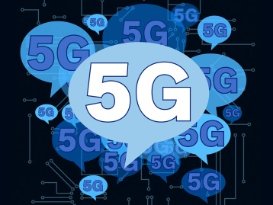
Emerging 5G technology that operates "1,000 times faster and with 100 times less latency" than its 4G counterpart will present digital marketers with new opportunities for consumer engagement, writes Noor Naseer. She contends that faster load times will enable marketers have a bigger presence on mobile, deliver more location-based promotions, enhance engagement with virtual and augmented reality experiences, and bolster business-to-business targeting.
MarTech Series 11/18/19
https://martechseries.com/mts-insights/guest-authors/five-ways-5g-will-change-digital-advertising/

