5G Will Transform OOH for Advertisers
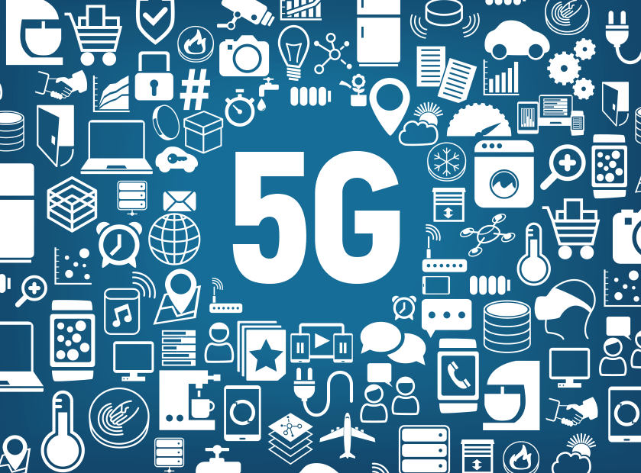
Outfront Media's Andy Sriubas discusses how out-of-home advertising will be affected by 5G, including the technology's ability to deliver fast, live content to digital billboards and displays. Advertisers will benefit from being able to make real-time decisions, such as delivering relevant ads to specific audiences in particular locations based on real events, such as a sports event ending earlier than anticipated, he says.
eMarketer 9/28/18
https://www.emarketer.com/content/how-5g-can-shake-up-ooh-advertising
Image credit:
https://c.slashgear.com/wp-content/uploads/2018/01/5G-IoT-839x620.png

