76ers Unveil New Nike Uniforms with Stubhub Ad
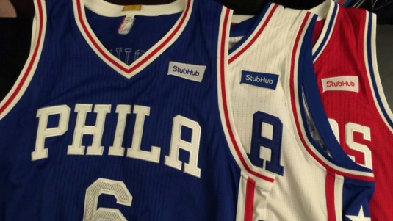
Next year's jerseys most distinguishing features: Red drop shadowing—and the 2.5-inch Stubhub ad placed opposite the Nike swoosh. The Sixers became the first NBA team to sign an on-jersey ad deal last May, playing a vital role in ushering in the new era of uniform advertising.
Advertising Age 8.1.17
http://adage.com/article/media/76ers-unveil-nike-uniform-stubhub-ad/309985/?utm_source=mediaworks&utm_medium=newsletter&utm_campaign=adage&ttl=1502226005&utm_visit=113450
Image source:
http://images.performgroup.com/di/library/omnisport/da/c1/sixers-stubhub-uniforms_6pa424wp12ml17ymo07hp7qxa.jpg?t=-1191807724

