A&E Networks' New Deal with AT&T Includes Viceland Channel
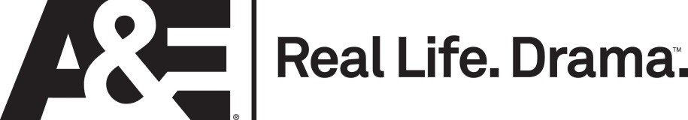
A&E Networks has struck a long-term carriage pact with AT&T for its U-Verse and DIRECTV services. The agreement includes carriage for A&E Networks' Viceland network, which is slated to debut in February in place of H2. Viceland, which is being developed in conjunction with Vice Media, was said to be a sticking point in negotiations.
Deadline.com 11/23/15
http://deadline.com/2015/11/att-offer-viceland-multiyear-carriage-deal-ae-networks-1201635707/

