A Face-Scanning Algorithm Increasingly Decides Whether You Deserve the Job
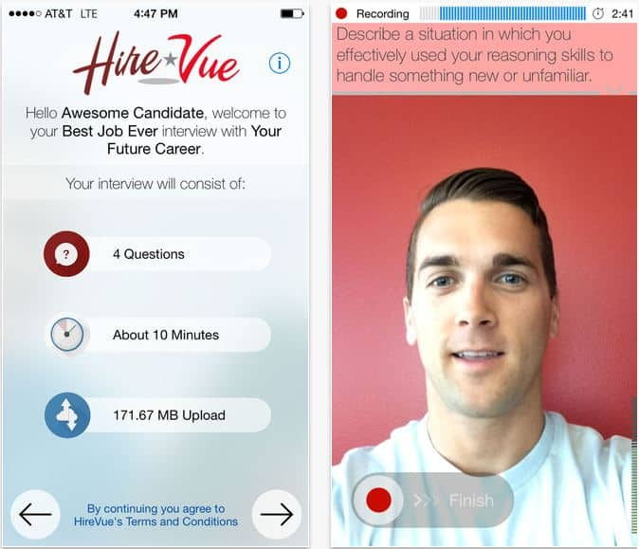
Designed by the recruiting-technology firm HireVue, the system uses candidates’ computer or cellphone cameras to analyze their facial movements, word choice and speaking voice before ranking them against other applicants based on an automatically generated “employability” score.
The Washington Post 10.22.19
https://www.washingtonpost.com/technology/2019/10/22/ai-hiring-face-scanning-algorithm-increasingly-decides-whether-you-deserve-job/
Image credit:
https://jebkinnison.files.wordpress.com/2016/10/hirevue.jpg

