A Framework to Overcome Implicit Bias
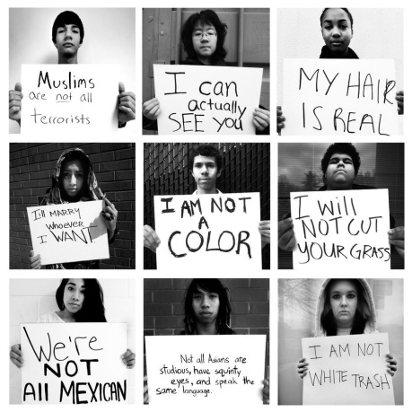
Anthony Hicks, APR, and Jaron Terry, APR and PRSA Fellow, write that PR leaders should make an effort to hire with diversity in mind to combat biases. The duo, who are members of PRSA's National Diversity and Inclusion Committee, note that for-profit and nonprofit companies have created a framework to overcome implicit biases, which can lead to negative employee evaluations based on race or gender.
PRSAY 8/31/17
https://prsay.prsa.org/2017/08/31/face-implicit-bias-to-create-a-more-diverse-pr-profession/
Image credit:
https://macrosw.files.wordpress.com/2015/06/image-implictbiasstereotypes.jpg

