A Media Buyer’s Primer on the FCC Spectrum Auction
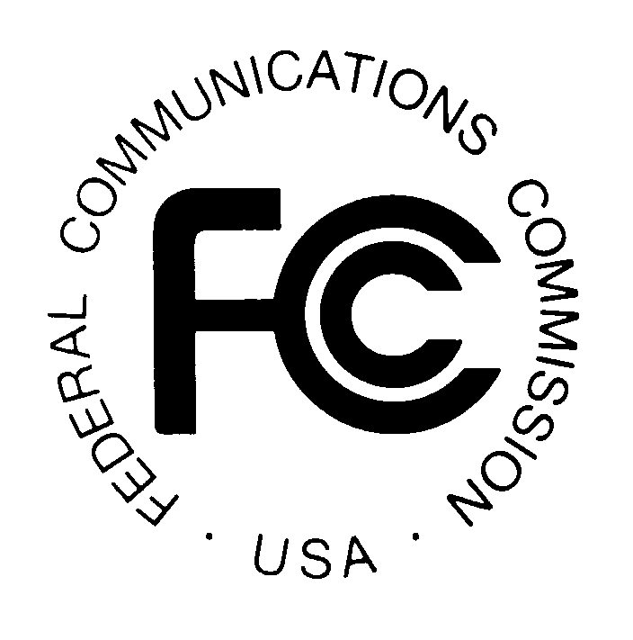
The FCC intends to buy up broadcast signals of TV stations around the country. If the price is right, the station gives up its space on the TV dial and either closes down or chooses another means of reaching viewers, such as switching to another broadcast frequency or choosing to air on cable only or going online. But if the offer isn’t high enough, station owners can choose to pass on the bid and continue broadcasting as before.
MediaLife 6.1.16
http://72.32.178.152/a-media-buyers-primer-on-the-fcc-spectrum-auction/

