A Quarter of Humanity Faces Looming Water Crises
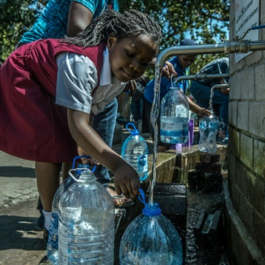
From India to Iran to Botswana, 17 countries around the world are currently under extremely high water stress, meaning they are using almost all the water they have, according to new World Resources Institute data. In those countries are several big, thirsty cities that have faced acute shortages recently, including São Paulo, Brazil; Chennai, India; and Cape Town, which in 2018 narrowly beat what it called Day Zero — the day when all its dams would be dry.
The New York Times 8.6.19
https://www.nytimes.com/interactive/2019/08/06/climate/world-water-stress.html?rref=collection%2Fbyline%2Fsomini-sengupta&action=click&contentCollection=undefined&region=stream&module=stream_unit&version=latest&contentPlacement=1&pgtype=collection&utm_source=CJR+Daily+News&utm_campaign=ee86a70ecc-EMAIL_CAMPAIGN_2018_10_31_05_02_COPY_01&utm_medium=email&utm_term=0_9c93f57676-ee86a70ecc-174383521
Image credit:
https://pixel.nymag.com/imgs/daily/intelligencer/2018/02/05/5-cape-town.w700.h700.jpg

