A Resurgence for Over-The-Air TV Antennas
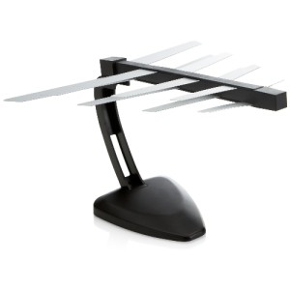
Over-the-air antennas are becoming more popular, so Scott Kramer tested out the ClearStream Eclipse Amplified Sure Grip Indoor HDTV antenna and the Mohu Leaf 50 Indoor Amplified HDTV antenna. The antennas lost reception occasionally, and he experienced delays, so Kramer advises supplementing an antenna with a streaming device, writing that consumers are "saving a lot of money by not paying outrageous cable bills."
Forbes 11/10/16
http://www.forbes.com/sites/scottkramer/2016/11/10/over-the-air-antennas-making-a-comeback/#6b723f661ad0
image source:
http://img.auctiva.com/imgdata/8/8/7/7/2/8/webimg/505627347_tp.jpg

