A Street Sign that Zaps Zika-Carrying Mosquitoes
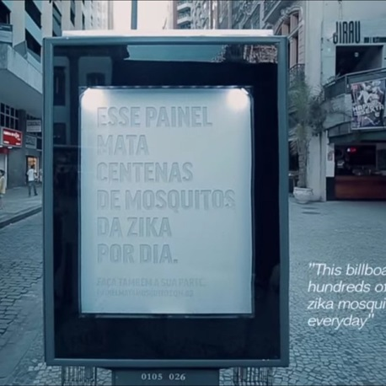
A clever OOH campaign on the streets of the city aimed to raise awareness of the virus while also protecting people. The signs attracted and trapped the species of mosquito known as a Zika carrier. The agencies involved also made the technology used to capture them available to anyone, so anyone could set up their own Zika mosquito killers.
MediaLife 9.16.16
http://cargocollective.com/mosquitokiller/English

