A Study of Consumers' Current Adoption of Voice
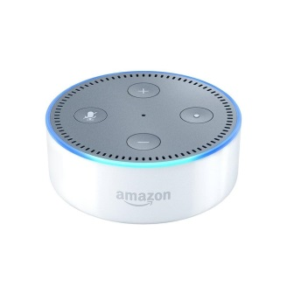
Publicis Media's "The Rise of Voice" study reports families are the biggest users of voice-enabled technology and, while more consumers are attempting to shop using voice, a "lack of visual confirmation, high potential for mis-ordering and inability to easily compare prices and availability are key barriers."
Adweek 4/4/18
http://www.adweek.com/agencies/parents-and-families-are-the-biggest-supporters-of-voice/
Image credit:
https://www.androidheadlines.com/wp-content/uploads/2016/11/amazon-echo-dot.jpg

