ACA to FCC: Prioritize Channel Unbundling
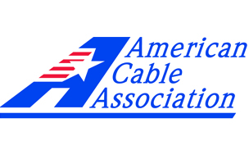
The American Cable Association has joined several indie programmers in asking the FCC to make the unbundling of channels a top priority. The ACA and its partners say the FCC should restrict large pay-TV operators from entering into unconditional “most favored nation” contracts with programmers.
FierceCable 1.30.17
http://www.fiercecable.com/cable/aca-indie-programmers-tell-fcc-s-pai-to-make-channel-unbundling-a-priority

