Ad Industry, Tech Companies Team Up To Battle Click Fraud
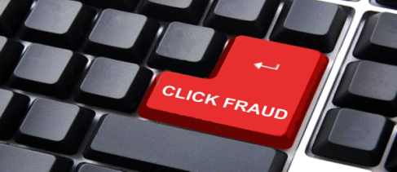
The Trustworthy Accountability Group is leading an effort to crack down on click fraud by partnering with Google, Facebook and Yahoo to get details of computer IP addresses that those companies have identified as conducting suspicious activity. Click-fraud activity could cost marketers $6.3 billion this year, according to research by the Association of National Advertisers.
PCWorld/IDG News Service 7/21/15
http://www.pcworld.com/article/2951252/online-ad-industry-tries-to-stamp-out-click-fraud.html

