Ad-Supported Viewing Makes Up Half Of Digital Video Viewers
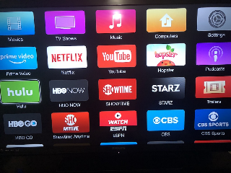
Nearly 128 million people in the US will watch advertising-based video-on-demand (AVOD) this year, a growth of 17.6%, over 2020. This means over 50% of all digital video viewers in the US are watching AVOD. By 2023, 259.8 million US adults will watch digital video content at least once per month, and those individuals will increasingly consist of AVOD viewers and subscribers.
eMarketer 9.16.21
https://www.emarketer.com/content/ad-supported-viewing-makes-up-half-of-digital-video-viewers?ecid=NL1001
Image credit:
https://www.ict-pulse.com/wp-content/uploads/2018/07/Video-On-Demand-ICT-Pulse.jpg

