Ads For Super Bowl 2023 Nearly Sold Out
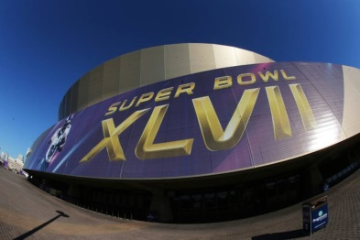
Fox Television Network says that 95% of its ad inventory for next year's Super Bowl is sold out, with some national 30-second spots fetching a price tag of more than $7 million. Advertisers have spent an average of around $6.5 million for a 30-second ad, and the game will have 28 new advertisers.
MediaPost Communications (free registration) 9.7.22
https://www.mediapost.com/publications/article/377454/super-bowl-95-sold-many-spots-topping-7m.html
Image credit:
https://cdn.elnacional.com/wp-content/uploads/2018/05/super-bowl-regresara-arizona-nueva-orleans-2023-2024_236941.jpg

