Advertisers Offered 6-second Ads by AMC Before "The Walking Dead"
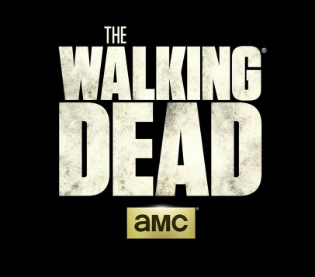
AMC is offering advertisers six-second ad spots at the start of seven episodes of the eighth season of "The Walking Dead." The network is considering either selling all seven ads to one advertiser, or running spots from different brands, AMC's Scott Collins said, adding, "It's the most powerful and engaged six-second moment you can buy on TV."
Variety 10/4/17
http://variety.com/2017/tv/news/walking-dead-six-second-ads-amc-tv-1202580620/

