Report: Advertising Poised For Healthy 2022 Growth
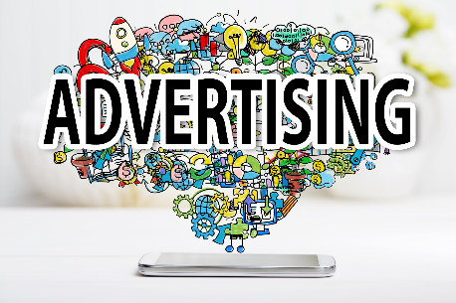
Cowen International predicts US advertising will witness its highest growth -- 7% -- in 10 years during 2022, while digital ads will increase 17% in the US to reach $221 billion. Based on its ad buyer survey, Cowen expects Amazon, TikTok and YouTube to see the biggest gains in advertising and forecasts that 33% of performance budgets will shift to other platforms as a result of iOS privacy changes.
MediaPost Communications (free registration) 1.19.22
https://www.mediapost.com/publications/article/370416/ad-buyers-bullish-on-youtube-amazon-tiktok.html

