After Hurricane Maria, AM Radio Makes a Comeback in Puerto Rico
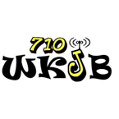
WKJB was being run by a motley crew of volunteer DJs. They called themselves “The Night Crew” and their improvised program was equal parts news program, variety show, and music channel. The DJs even took call-ins from listeners whose landline telephones still worked despite the power outage. Since the night of Hurricane Maria, “The Night Crew” has aired every night, raising the volunteer DJs to the status of folk heroes in Mayagüez.
Columbia Journalism Review 4.23.18
https://www.cjr.org/united_states_project/hurricane-maria-puerto-rico-radio.php?Daily

