AI Deepfakes Plague Newsrooms, Reporters
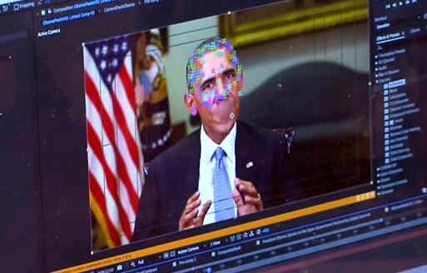
Only 10% of the more than 1,000 videos CBS News has sifted through related to the latest Israel-Hamas war can be used, says CEO Wendy McMahon, who notes the volume and sophistication of AI-generated content and misinformation being supplied to newsrooms is increasing. Many deepfake news stories posted on social media that feature real reporters have fooled viewers and have left newsrooms working to combat this misinformation.
Axios 10/12/23
https://www.axios.com/2023/10/12/mcmahon-misinformation-cbs-deep-fakes-bfd
Image credit:
https://i0.wp.com/thetechhacker.com/wp-content/uploads/2019/09/Deepfake-technology.png?fit=1000%2C640&ssl=1

