AI Voice Devices Offer Marketers New Access to Consumers
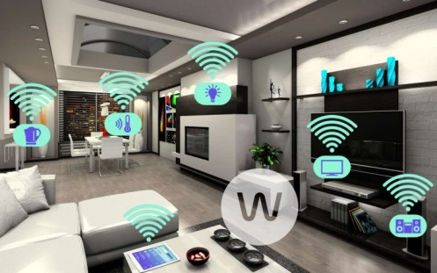
Smart home devices have quickly arisen as an outlet for artificial intelligence technology, and marketers are looking into opportunities to share branded content through them. Video has been popular, but voice is becoming an integral way we interact with technology, said Greg Hedges of digital agency Rain.
Adweek 11/13/16
http://www.adweek.com/news/technology/smart-home-devices-are-giving-brands-whole-new-way-advertise-174569
image source:
http://www.megaleecher.net/sites/default/files/images/weebee-smart.jpg

