Algerian Journalist Ihsane El Kadi Sentenced To Five Years
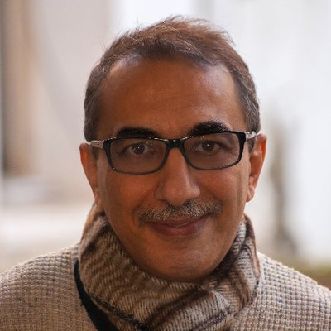
High-profile Algerian journalist Ihsane El Kadi has been sentenced to three years in prison by a court in Algiers, which has accused him of “foreign financing of his business”, AFP reported. El Kadi, who owns one of the few independent media groups in the country and is critical of the government, was given a sentence of five years, three of which he must serve in jail.
AlJazzera 4.2.23
https://www.aljazeera.com/news/2023/4/2/algerian-journalist-ihsane-el-kadi-sentenced-to-five-years
Image credit:
https://pbs.twimg.com/profile_images/813878137608171524/AeZNCeek_400x400.jpg

