All-Female Superhero Toy Line Gets its Own Animated Series
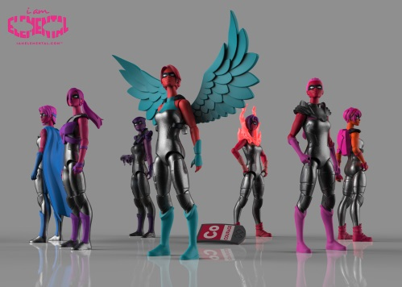
Jim Henson Co. has announced plans to turn the all-female superhero action figure toy line IamElemental into an animated series. "We felt that there weren't enough examples in the media of females saving the day, and we wanted kids to be create their own stories with females at the center of the story," IamElemental founder Julie Kerwin said.
Syfy Wire 11/7/17
http://www.syfy.com/syfywire/jim-henson-co-developing-iamelemental-action-figure-line-as-animated-series
Image credit:
http://toybook.com/wp-content/uploads/2014/08/IAE.jpg

