All the Numbers on Who’s Listening to Radio
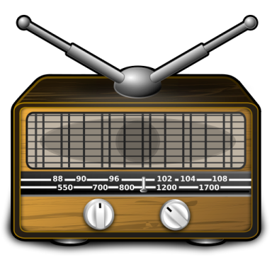
Here are some of the highlights: Radio has a higher reach of all demographics over other platforms. Demand for streaming continues to grow, but 55 percent of radio listening still comes from AM/FM stations. Of those listening to streaming audio, more than half still listen to traditional radio. Traditional radio remains the best way for reaching consumers close to point of purchase, as only a third of streaming audio is heard away from home.
MediaLife 6.9.16
http://72.32.178.152/numbers-whos-listening-radio/

