Allen Bids $10B For Disney Units
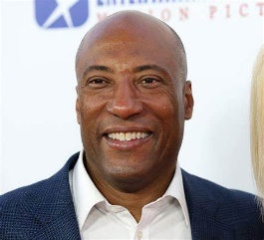
Byron Allen has offered $10 billion to Disney for FX, the National Geographic Channel and the ABC broadcast network. Disney "has made no decision with respect to the divestiture" of any properties, the company stated on Sept. 14, following a rumor that it might sell ABC to Nexstar.
TheWrap 9/15/23
https://www.thewrap.com/byron-allen-10-billion-offer-disney-abc-fx-national-geographic/
Image credit:
https://sandrarose.com/wp-content/uploads/2019/10/Byron-Allen-wenn33992917.jpg

