Larry Wilson's Alpha Media Blows Past 100 Station Mark
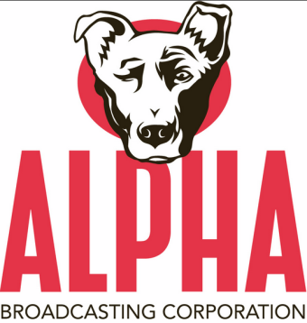
Larry Wilson's Alpha Media has entered into an agreement to purchase 34 radio stations in eight markets from Morris Communications. The markets include: Topeka, KS; Salina, KS; Amarillo, TX; Palm Springs, CA; Anchorage, AK; Wasilla, AK; Grays Harbor-Hoquiam, WA; and Wenatchee-Columbia River, WA. When all pending deals are completed, it will bring the total number of stations owned by Alpha Media to 135.
Radio Ink 5.19.15
http://radioink.com/Article.asp?id=2929478&spid=24698

