Altice-Cablevision Merger Approved by FCC
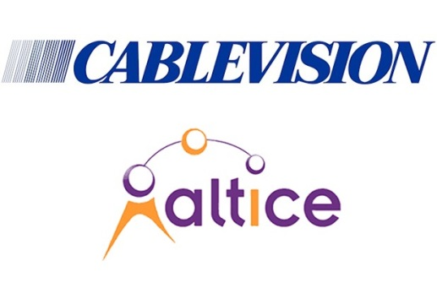
Altice's $17.7 billion acquisition of Cablevision has advanced following Federal Communications Commission approval. The deal was approved on delegated authority, with the FCC noting that "the transaction is unlikely to have adverse competitive effects." The acquisition must still be approved by New York City and the state of New York.
Multichannel News 5/3/16
http://www.multichannel.com/news/fcc/fcc-approves-altices-purchase-cablevision/404664

