Amazon Fire TV To Integrate Into Cars By Year's End
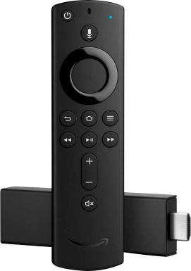
At CES, the company announced a new Fire TV Edition, able to power soundbars and be integrated into cars by late 2020. Amazon said it is partnering with Fiat Chrysler and BMW to bring Fire TV-enabled rear-seat TV sets to those vehicles. The Fire TV system will stream from Wi-Fi and the car's built-in LTE connection, but Amazon plans to offer offline viewing, too.
Media Post Communications 1.8.20
https://www.mediapost.com/publications/article/345454/amazon-fire-tv-to-integrate-into-cars-by-years-en.html?utm_source=Listrak&utm_medium=Email&utm_term=Amazon+Fire+TV+To+Integrate+Into+Cars&utm_campaign=Rising+NFL+Ratings+Boosting+Broadcast+Nets
Image credit:
https://www.mydomaine.com/thmb/FRz-ULaNnJz7qDnHj6lIrsPApII=/883x1255/filters:no_upscale():max_bytes(150000):strip_icc()/AmazonFirestick-6aa32216879649baa56bb8c03347714a.jpg

