Amazon’s Oscar Nomination for Best Picture is a First for a Streaming Service
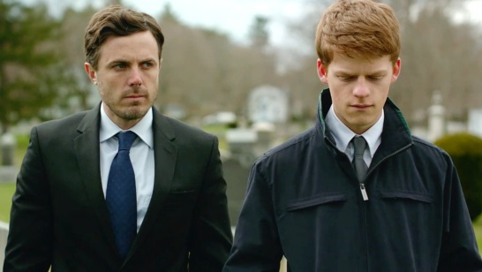
Amazon’s "Manchester by the Sea" landed an Oscar nomination for best picture today, making Amazon the first streaming service to earn the honor. As Variety points out, the nomination comes almost one year after Amazon made headlines by bidding a whopping $10 million for the rights to the film.
Fierce Cable 1.24.17
http://www.fiercecable.com/broadcasting/amazon-s-oscar-nomination-for-best-picture-a-first-for-a-streaming-service

