Amazon May Win Some Exclusive NFL Programming
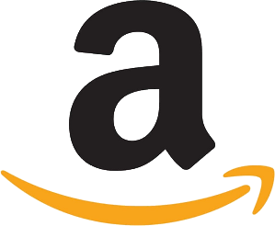
Amazon's Prime Video service may gain exclusive rights to stream some National Football League events on Thursday nights in 2022, The Wall Street Journal reports. Current agreements with ESPN, Fox, CBS and NBC are reportedly likely to cover Monday and Sunday games for 11 years.
Reuters 3.3.21
https://www.reuters.com/article/us-amazon-prime-video-nfl/amazon-in-talks-with-nfl-for-prime-video-rights-deal-wsj-idUSKBN2AV2SR

