AMC Movie Theaters Will Launch Online Video Store
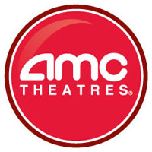
The AMC Entertainment movie chain will let US internet users rent or buy films after their theatrical windows end under rights agreements completed with Disney, Sony, Warner Bros., Paramount and Universal, CEO Adam Aron announced. AMC will charge between $3 and $5.99 to rent films online from a library of about 2,000 current and older movies.
Variety online 10/14/19
https://variety.com/2019/digital/news/amc-entertainment-movies-on-demand-1203370464/

