AMC Networks Plans To Launch Ad-Supported Version of AMC Plus
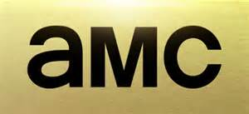
AMC Networks said it is planning to launch an ad-supported version of its AMC Plus streaming service by October. Advertisers will also be able to reach viewers of some of AMC's targeted streaming services -- Shudder, IFC Films Unlimited and Sundance Now -- if those viewers subscribe via the AMC Plus bundle.
Next TV/Broadcasting+Cable 4/17/23
https://www.nexttv.com/news/amc-networks-plans-to-launch-ad-supported-version-of-amc-plus?utm_term=A25693A1-51B6-4112-BDE4-56BD420E983F&utm_campaign=C74FC4FA-5D4D-4151-8915-3043BA411DBE&utm_medium=email&utm_content=98EFE1CA-8E90-4C7C-BA25-7E09B19BD98A&utm_source=SmartBrief

