Analyst Predicts Roku Will Hit 80 Million Subscribers By 2025
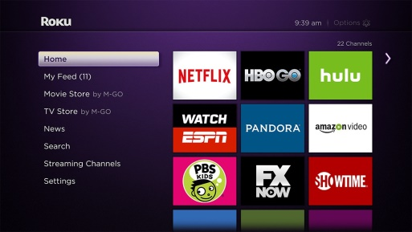
Recently, Roku said it reached 30.5 million subscribers, up nearly 40% from the year before. Roku estimates annual revenue this year will climb to around $1 billion. Roku’s growth is trending faster than Netflix's at this point. Netflix currently has 60.1 million U.S. subscribers and 140 million globally.
MediaPost 8.27.19
https://www.mediapost.com/publications/article/339806/analyst-predicts-roku-will-hit-80-million-subscrib.html?utm_source=Listrak&utm_medium=Email&utm_term=Roku+To+Hit+80M+Subs%2c+%244.5B+In+Rev+By+%26%23039%3b25&utm_campaign=Agency+Experts+Handicap+The+Fall+Season
Image credit:
https://i1.wp.com/cordcuttersnews.com/wp-content/uploads/2015/10/Roku-Home-MyFeed-v7.jpg

