And The Super Bowl Brand Winners On Social Are ...
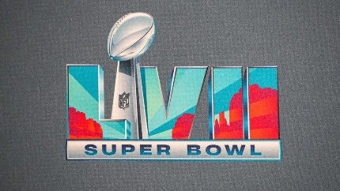
Tubi, Bud Light and Doritos were the brands that generated the most social media mentions among Super Bowl advertisers during the game but Apple, as halftime show sponsor, attracted the most mentions overall, per social listening analysis by Emplifi. Apple also attracted the most engagement on mentioned posts while Dunkin' generated the most impressions, at a whopping 507 million, followed by Apple at 331 million and FanDuel at 101 million.
SmartBrief/Marketing 2/14/23
https://corp.smartbrief.com/original/2023/02/which-brands-won-the-social-media-super-bowl?utm_term=A25693A1-51B6-4112-BDE4-56BD420E983F&utm_campaign=E907F06B-D9B7-4404-A803-BC63A3E7EE10&utm_content=07E5895D-833D-4573-8AD5-4C5ACEAF80A7&utm_source=brief
Image credit:
https://sportshub.cbsistatic.com/i/r/2023/02/11/4feb295e-519f-4d74-b0a1-8ce49cb72c5d/thumbnail/1200x675/6c899a2c1edff80ba8f28ce41ae41d31/super-bowl-logo-g.jpg

