AP Stylebook Addresses Gender for Writing Clarity
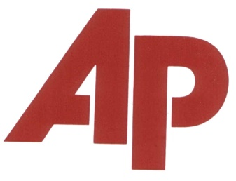
Jaron Terry, APR and Fellow PRSA, discusses the 2017 Associated Press Stylebook's introduction of a gender section, which informs readers of the spectrum of gender and provides tools for writing about the topic, and the importance of this new section for PR professionals. "[As] recognition that spoken language uses 'they' as a singular, and [because] we also recognize the need for a pronoun for people who don't identify as a he or a she," said Paula Froke, AP Stylebook editor.
PRSAY 8/11/17
https://prsay.prsa.org/2017/08/11/breaking-down-the-ap-stylebooks-new-rules-on-gender/

