Apollo Nears $3 Billion Deal to Buy Cox TV Stations
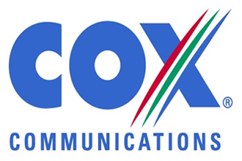
Cox, a privately held media conglomerate whose holdings span automotive websites, newspapers and cable TV, has been seeking to exit the regional TV sector, which is going through a wave of consolidation. Operators are looking for scale to counter the rise of online streaming and the shift of advertising dollars to the internet.
Reuters 2.10.19
https://www.reuters.com/article/us-coxtv-m-a-apollo-glo-mgmt/exclusive-apollo-nears-3-billion-deal-to-buy-cox-tv-stations-sources-idUSKCN1PZ0QX?utm_source=Listrak&utm_medium=Email&utm_term=Apollo+Nears+%243B+Deal+To+Buy+Cox+Stations&utm_campaign=Apollo+Nears+%243B+Deal+To+Buy+Cox+Stations

