Apple, Google Play Growing Role in Delivering News
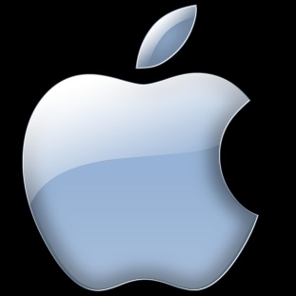
Apple's News application -- which will combine content from publishers such as the New York Times, the Atlantic, Wired and ESPN -- is just the latest indication of the growing role new-media companies, including Facebook and Google, are playing in publishing traditional media content. "Some analysts have pondered that a new-media power such as Facebook, Google or Apple could acquire a traditional media stalwart," writes Jon Friedman.
Investor's Business Daily 7/15/15
http://news.investors.com/technology/071515-761711-old-and-new-media-increasingly-teaming-up.htm?src=3MC761711

