Apple, Qualcomm Settle Patent Dispute
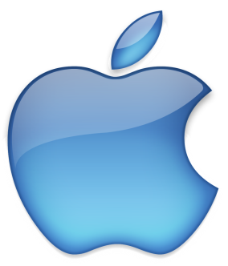
Apple and Qualcomm have settled a yearslong, multibillion-dollar patent-licensing dispute. Apple will pay Qualcomm an undisclosed fee, Qualcomm will give Apple a six-year license to its patents -- with an option for a two-year extension -- and Qualcomm will also enter into a multiyear chip supply agreement with Apple.
ZDNet 4/16/19
https://www.zdnet.com/article/apple-qualcomm-agree-to-end-all-patent-litigation/

