Apple TV Plus Had Nearly Five Times More Churn Than Netflix in 2021
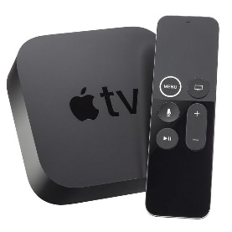
With much of its subscriber base adding its service on promotions tied to Apple product purchases, Apple TV Plus has the highest churn rate in the U.S. subscription streaming business at nearly 10.4%, according to new data published by research company Antenna.
Next TV 3/8/22
https://www.nexttv.com/news/apple-tv-plus-had-nearly-10-times-more-churn-than-netflix-in-2021

