AR, Ephemeral Content to Help Define Social Media in 2018
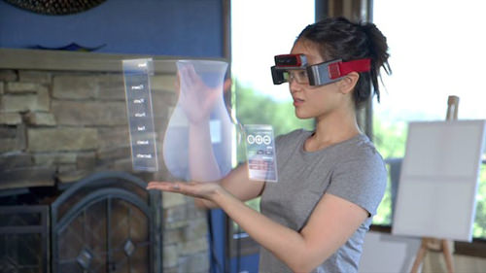
Augmented reality and ephemeral content, such as the disappearing stories popularized by Snapchat, will be big social media trends in 2018, writes Maddy Osman. Instagram stories and influencer marketing also will continue to grow in importance as brands seek a meaningful connection with Generation Z.
AdNews (Australia) 11/13/17
http://www.adnews.com.au/opinion/nine-social-media-trends-predicted-in-2018-for-marketers
Image credit:
http://media02.hongkiat.com/augmented-reality-smart-glasses/meta.jpg

