ASCAP Pushes Back Against Radio In Rate-Setting Fight
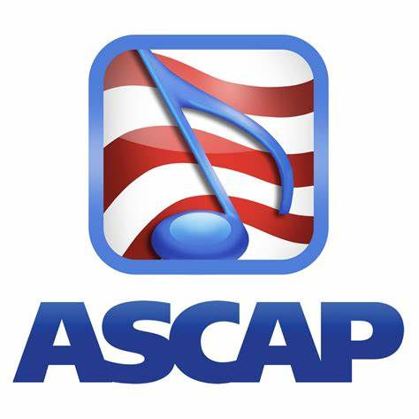
License fees paid by radio stations to American Society of Composers, Authors, and Publishers members should reflect ASCAP's share of songs played on radio stations, ASCAP told a New York court last week as the royalty organization's battle over royalties with the Radio Music License Committee continues. ASCAP has yet to set rates for 2022 to 2027, claiming it needs to know what radio pays rivals GMR and SESAC before it can set fair rates.
Inside Radio 3/4/24
https://www.insideradio.com/free/ascap-tells-court-it-should-get-more-than-what-gmr-or-sesac-collect-from-radio/article_2308c224-da00-11ee-aa2e-3764057e8a57.html

