AT&T Set to Launch 3 DIRECTV OTT Streaming Services
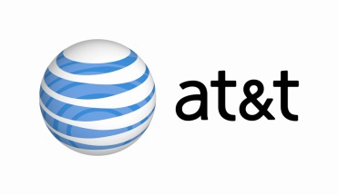
AT&T is gearing up to release three over-the-top services in Q4, the company announced. DIRECTV Now is a paid service for wired and wireless devices, DIRECTV Mobile is a paid service designed for smartphones with any carrier, and DIRECTV Preview is a free, ad-supported service that will carry some of DIRECTV's content. Pricing and content for the contract-free services have not yet been announced.
Multichannel News 3/1/16
http://www.multichannel.com/news/content/att-take-directv-over-top/402950

