AT&T Sells Its 9.5% of Hulu for $1.4B
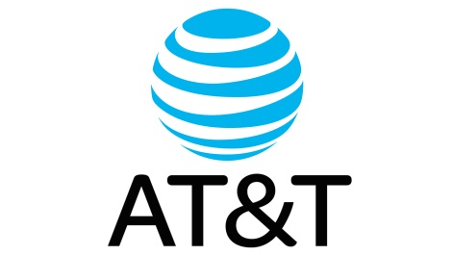
The Walt Disney Co. wound up with a 60% share after its purchase of much of 21st Century Fox, which included Fox’s Hulu stake. NBCUniversal parent Comcast Corp. owns 30%. There is speculation that Comcast will sell too, leaving Disney the sole owner and perhaps making Hulu’s content much more Disney-centric.
TVNewsCheck 4.16.19
https://tvnewscheck.com/article/top-news/233994/att-sells-hulu-shares/?utm_source=Listrak&utm_medium=Email&utm_term=AT%26amp%3bT+Sells+Its+9.5%25+Of+Hulu+For+%241.4B&utm_campaign=%27Game+of+Thrones%27+Breaks+HBO+Rating+Records

