AT&T TV and HBO Max May Merge
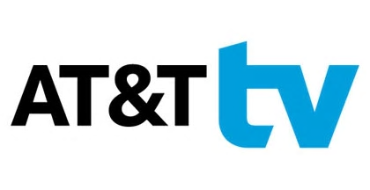
AT&T chief operating officer John Stankey told a virtual industry audience Wednesday that its upcoming subscription streaming service, HBO Max, could eventually be paired with its new IP-based pay TV service, AT&T TV, as the TV business continues to move toward a more compact streaming environment.
Next TV 5.13.20
https://www.nexttv.com/news/atandt-tv-and-hbo-max-may-eventually-be-merged-into-one-service

