Augmented Reality Can Expand Audiences
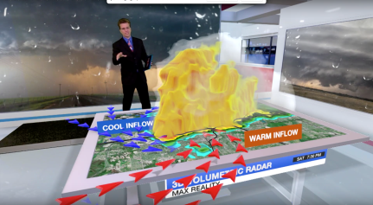
Meteorologists who embrace augmented reality can enhance their storytelling and keep viewers, particularly younger demographics, tuned in, and not just on TV, according to experts who participated in a TVNewsCheck Webinar, The New Weather Storytelling with Augmented Reality. Talent coach and consultant Tim Heller, of HellerWeather, showed a scene he created while working at Disney-owned KTRK Houston, to explain how AR draws viewers into the presentation.
TVNewsCheck 11.30.20
https://tvnewscheck.com/article/top-news/256335/augmented-reality-can-expand-audiences-and-set-newscasts-apart-without-breaking-the-bank/?utm_source=Listrak&utm_medium=Email&utm_term=Augmented+reality+can+expand+audiences+and+set+newscasts+apart+without+breaking+the+bank&utm_campaign=BIA%3a+Local+Advertising+To+Rebound+In+%2721
Image credit:
https://lh6.googleusercontent.com/_A781cdDRtKwm1aRvod4vY-ZDsSN4wVp69pPzX2da3gQzapn2gSAxoMpoF0jgsaOB6suOjg17c2LQm5Qfv1h7sw4dlBSp9TjimjvPPrboVNEb0dIi5lV1NwuTctR9Finu246ya2m

