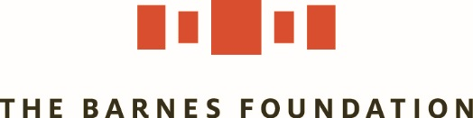

Internships
We offer summer, spring, and fall internships, in a variety of departments, for undergraduate and graduate students. Our interns work with experts in their fields, gain valuable job experience, and engage in meaningful work.

https://www.barnesfoundation.org/about/careers-and-volunteering

Application Deadlines:
Summer internship program: February 1
Fall internships: June 1
Spring internships: October 1

Interns at the Barnes may contribute in the following areas:

- Business Development
- Collections & Exhibitions
- Community, Youth, & Family Programs
- Conservation
- Development
- Editorial/Publications
- Education
- Finance
- Graphic Design
- Human Resources
- Legal
- Marketing & Social Media
- Public Programs
- Public Relations
- Registration
- Retail

Internship Funding:
We are pleased to offer a select number stipends of $2,500 for undergraduate summer interns, with the goal of making internship opportunities more accessible to students. We encourage students of color, those who are underrepresented in the cultural sector, and students from low-income backgrounds to apply.

Summer Internship Program: February 1 application deadline
The summer internship program runs from the first week in June through the second week of August. Interns must commit to a minimum of eight consecutive weeks and two days per week, and must be on-site or available to attend enrichment activities every Friday during the program.

Fall Internships: June 1 application deadline
Spring Internships: October 1 application deadline
Both fall and spring internships last eight to ten weeks. Interns must commit to a minimum of eight consecutive weeks and two days per week.

A complete application includes:
- Application Form
- Cover Letter
- Résumé/ CV
- Transcripts*
- Two Letters of Recommendation**
*Official transcripts are preferred; unofficial transcripts are acceptable.
**Letters of recommendation may be also be emailed in doc or pdf format to internship@barnesfoundation.org.

Internship applicants must be currently enrolled in undergraduate or graduate studies, or must be recent graduates.

Notification:
If you are selected to move forward with the application process, a Barnes staff member will contact you for an interview. We let all applicants know the final status of their applications about six weeks after the application deadline.

Have other questions? Email us at internship@barnesfoundation.org.

