BBBA Contains Local Journalism Employment Incentives
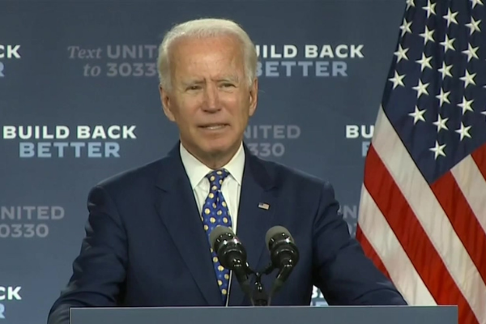
News organizations employing local journalists for at least 30 hours a week could get as much as $25,000 in tax credits under the Build Back Better Act's latest iteration. Another provision makes sound recording production costs completely deductible in the year they occur.
Deadline Hollywood 11.3.21
https://deadline.com/2021/11/build-back-better-act-local-news-sound-recordings-1234867570/
image credit:
https://dmlo.com/wp-content/uploads/2021/11/Build-Back-Better-Act-Framework.png

