BEA Uses Students' Creative Work To Judge Schools
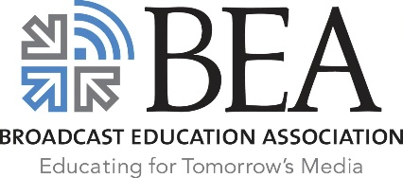
The Broadcast Education Association has revealed its 2022 school rankings, based for the first time ever on students' creative achievements. Arizona State University led the overall list.
TV Tech 3/31/22
https://www.tvtechnology.com/news/bea-announces-first-annual-school-rankings-based-on-student-achievement?utm_source=SmartBrief&utm_medium=email&utm_campaign=45863C53-9E40-4489-97A3-CC1A29EF491D&utm_content=51835DA3-99AA-4CDE-9631-9AA4B0BBEDA3&utm_term=a25693a1-51b6-4112-bde4-56bd420e983f

