Beauty Brands Offered AR Try-On Ads by Meredith
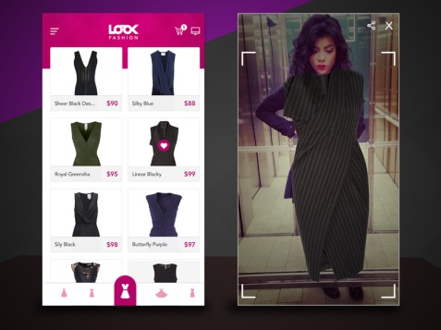
Meredith Corporation's InStyle magazine is opening its augmented reality beauty try-on experience, which print and digital readers can activate via a QR code, to advertisers. The AR feature is being integrated into ad units across digital properties and Meredith's Rachel Reed says, "If a makeup brand came to us and wanted to do something, we could help build out that AR try-on and drive right to their site."
The Drum (free registration) 9/24/19
https://www.thedrum.com/news/2019/09/24/meredith-pitching-beauty-advertisers-ar-try-experiences
Image credit:
https://cdn.dribbble.com/users/1288384/screenshots/3102437/01.jpg

