Behavioral Ad Targeting Gets Thumbs Up from CPG Brands
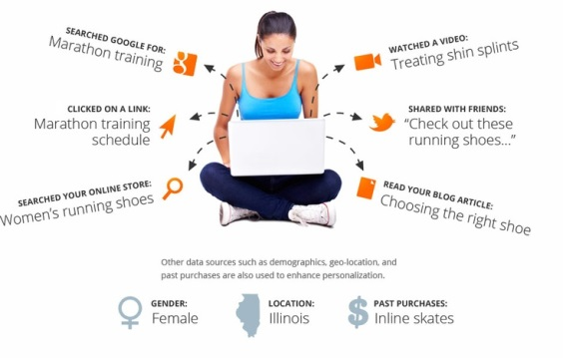
Consumer packaged goods brands such as Procter & Gamble are shifting from demographic targeting to using behavioral data to target ads at consumers. Johnson & Johnson achieved a 7% increase in sales of Aveeno products due to behavioral targeting, Chief Marketing Officer Alison Lewis told Dmexco attendees.
AdExchanger 9/18/17
https://adexchanger.com/advertiser/cpg-brands-replace-demographic-targeting-behavioral-targeting/
Image source:
http://www.amadoradvertising.com/wp-content/uploads/2016/01/behavioral-targeting.jpg

