"Better Call Saul" Tops List of Time-Shifted Shows
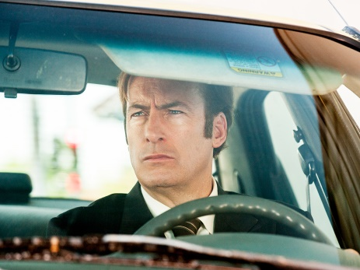
AMC's "Better Call Saul" was the top time-shifted show of 2016, bringing in 278.7% more viewers thanks to time shifting. FX's "American Horror Story" ranked second, and "The People v. O.J. Simpson: American Crime Story" came in third, with time-shifting increases of 245.5% and 238.6%, respectively.
Multichannel News 12/28/16
http://www.multichannel.com/news/audience-measurement/top-time-shifted-shows-saw-bigger-lift-2016/409862

